Main Parameter |  | Working Manner |  | Product Standard
CPU | ARM(STM32) | power supply | rechargeable lithium battery | color | white grey
working frequency | 134.2KHz/125KHz | communication mode | bluetooth and USB | package size | 26.5*20*5cm
screen | 128*32 OLED | continuous working time | 12 hours | G.W. | 552.6g
system clock | built-in | storage temperature | -30°C-65°C | N.W. | 222.2g
buzzer | built-in | operation temperature | -30°C-50°C | button number | 3
data storage | 7000 records | operation humidity | 5%～90% | Indicator light | yellow, green
Others
reading standard | ISO11784/5 FDX-B and HDX, ID64
operation language | Chinese Version: simplified Chinese, traditional Chinese, English
operation language | Central Asia Version: Kazakh, Russian, Mongol, English
operation language | European Version: French, German, Spanish, Portuguese, Dutch, Danish, English
International certification | CE, ROHS
Guarantee | one year
reading head | one-dimensional bar code reading head (optional)
accessories | packing box, charger cable, a standby battery
reading distance | Ear tag: 17cm for FDX-B , 20cm for HDX  microchip : 9cm,

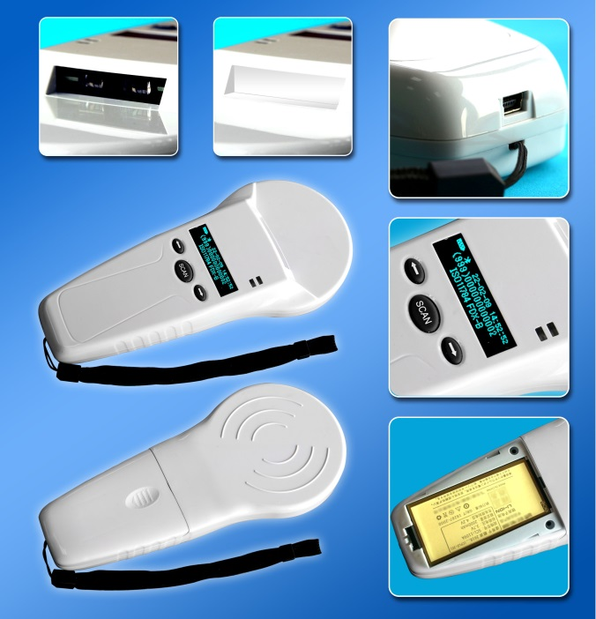

Sales Hotline
Tel: 86-0510-85282218-8009
Email: lisa.qiu@fofia.com
Mob: 15949235501

Company Profile

Wuxi Fofia Technology Co., Ltd was founded in 2002. It’s a provincial high-tech enterprise in Jiangsu. We focus on the research, development, production and sales of the products in animal identification technology field.

Company Advantages

Wuxi Fofia Technology Co., Ltd is a leading supplier of animal identification products in Asian and Pacific area. We provide professional pet ID microchips, animal electronic ear tags, readers, handheld equipment and system integration. All our animal identification products are developed and produced based on 134.2 KHz ISO11784/85 FDX-B standards. We have been approved by the International Committee for Animal Recording (ICAR). We devote ourselves to providing RFID solutions to animal tracking, animal husbandry informatization and food safety & source-tracing management.

Strategic Cooperation

Wuxi Fofia Technology Co., Ltd will develop into a company that can provide complete solutions including IC card, equipment, application software and system integration. We’re committed to the development and promotion of animal identification technology. We’ll win customers’ trust with our high-quality products and first-class service. We warmly welcome the direct users of food safety source-tracing project implementation and system integrators to cooperate with us. We’ll try our best to provide the best solution of food safety & source-tracing for you.

www.fofiatag.com
PT580 is a new generation of multi-functional handheld animal ID reader designed and produced exclusively by Fofia Tech in 2010.
It can read RFID chips, ID numbers as well as one-dimensional barcode. It is applied to the pet and animal identification market with high cost-efficiency, cute appearance. The unique three-button design gives users the biggest convenience in single hand operation.
After reading some RFID tags or one-dimensional bar codes (optional), it can display the information and the reading time while storing data. User can transmit the information to the PC automatically through USB and bluetooth.
PT580 can read all the tags that meet ISO11784 FDX-B, ID64 and HDX standards.

PT580 RFID Handheld Reader

无锡市富华科技有限责任公司
WUXI FOFIA TECHNOLOGY CO.,LTD.

